Notes on Haas 5 axis post processor.

Tuesday, 20 February 2007

- You must post process the PROGRAM group and not the individual operations, otherwise the rotary axis will not be optimised and the A-axis will not be forced out correctly.

- If the use uses new manufacturing templates retrieved from the default system and the user does not specify the following setting:
- Clearance Plane
- Speed/Feeds
- Tool Number

Then the post processor will error out.
The user should check the NX LOG for errors.
The listing will indicate the areas that have not been set correctly in the operation

EG:-

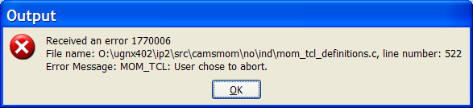
In the NX Log file:-

+++ Abort Message :

*** Spindle Speed Not set ***
*** in operation A-45 ***

Load the BandB_mfg.prt test part and post process the Program Groups

This is and assembly and uses bandb.prt
The machine tool has an auto-tool changer of 20 tools.
When the controller encounters over 20 tools the machine will stop and you will have to load the tools manually.

If you use the tools from the template, then you will have to renumber them accordingly.

